# SSIS DataFlow

Overallrun

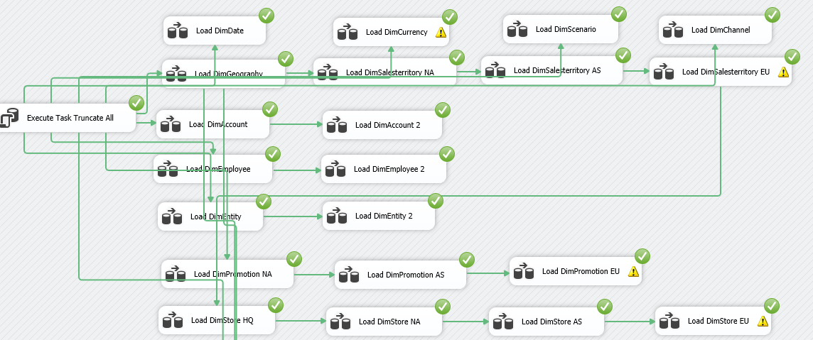

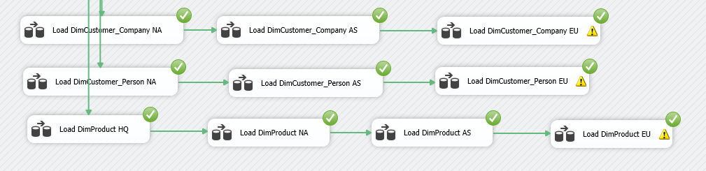

# Individual JobRuns

DimDate

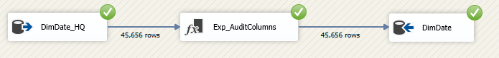

DimCurrency

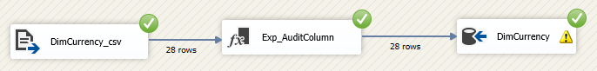

DimScenario

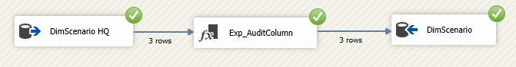

DimChannel

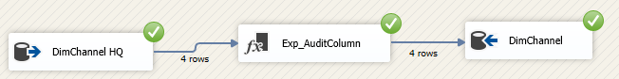

DimGeography

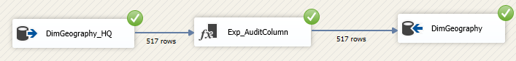

DimSalesTerritory

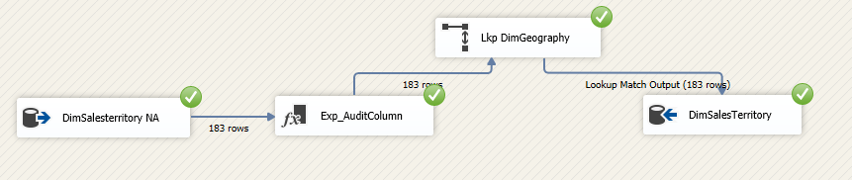

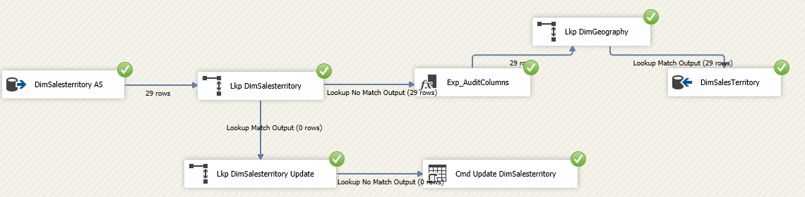

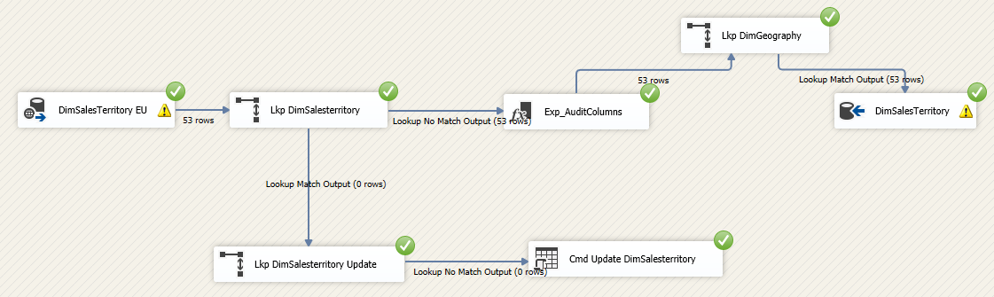

DimAccount

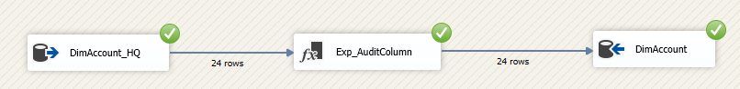

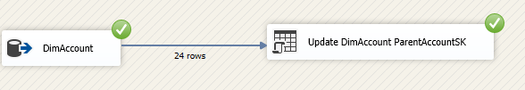

DimEmployee

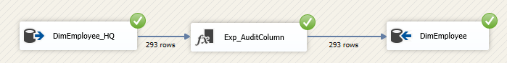



DimEntity

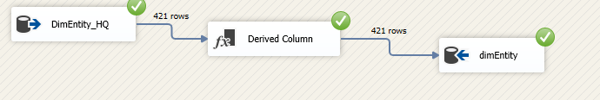

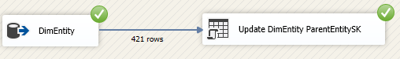

DimPromotion

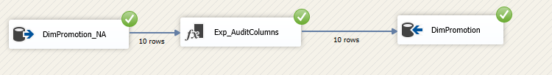

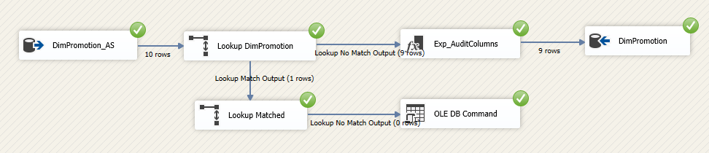

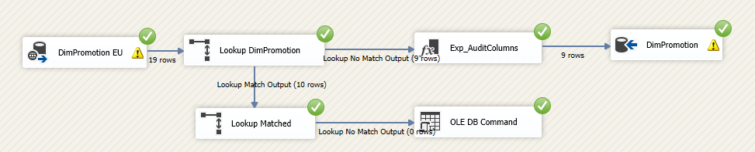

DimStore

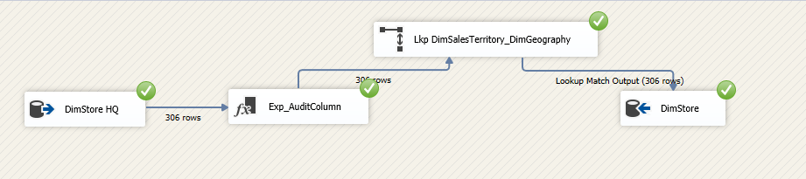

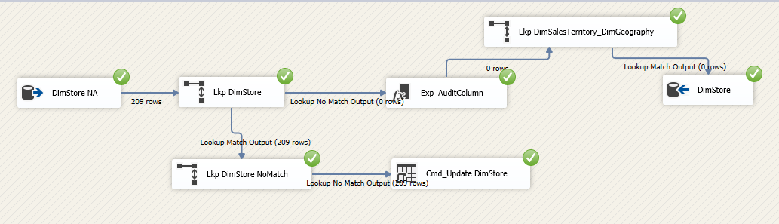

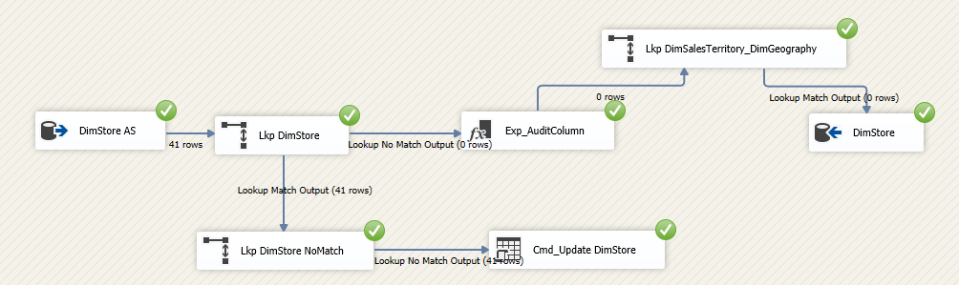

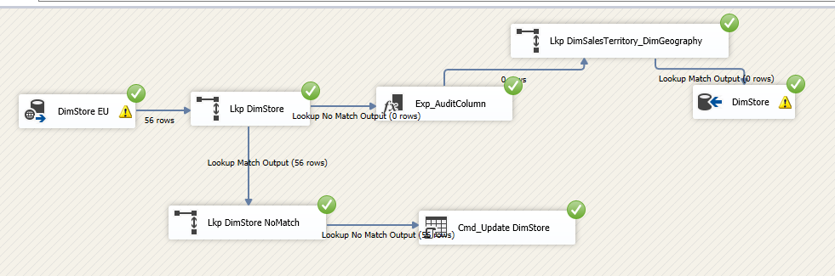

DimCustomer_Company

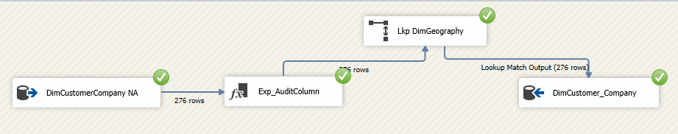

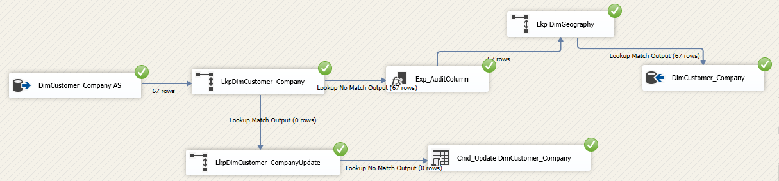

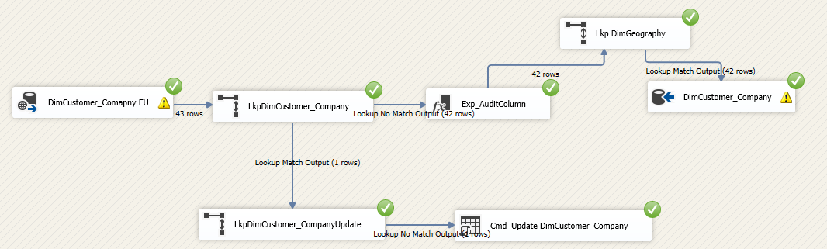

DimCustomer_Person

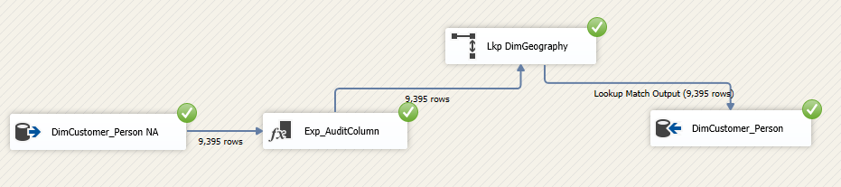

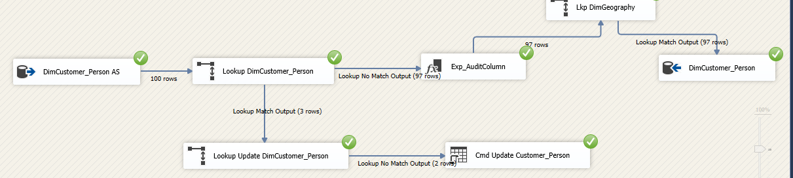

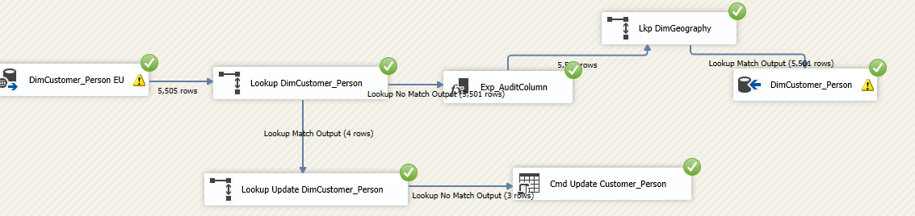

DimProduct

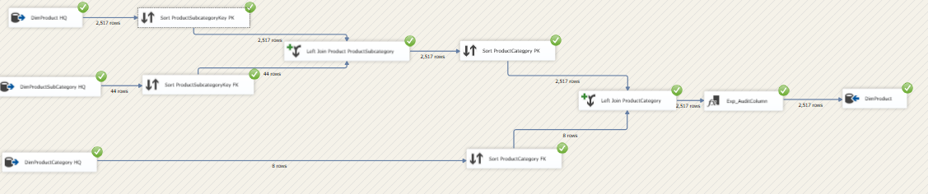

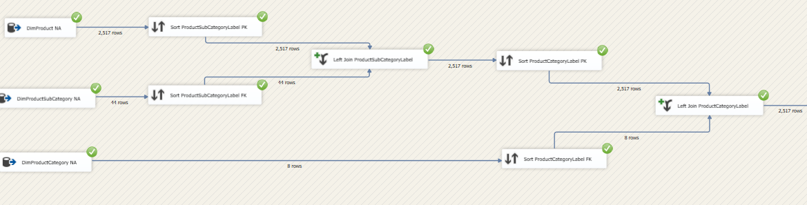

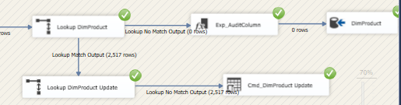

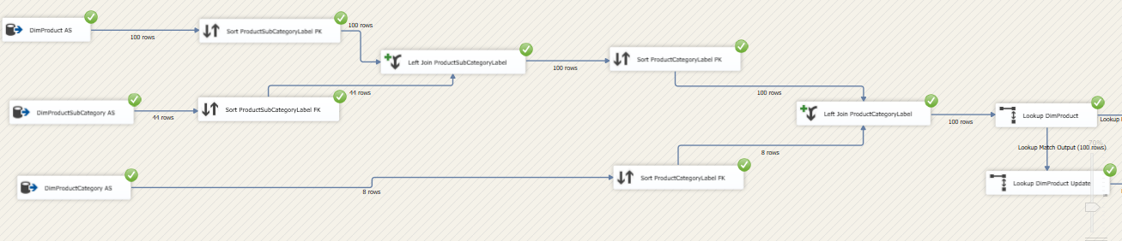

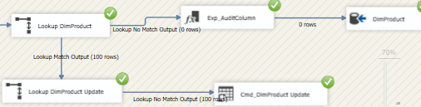

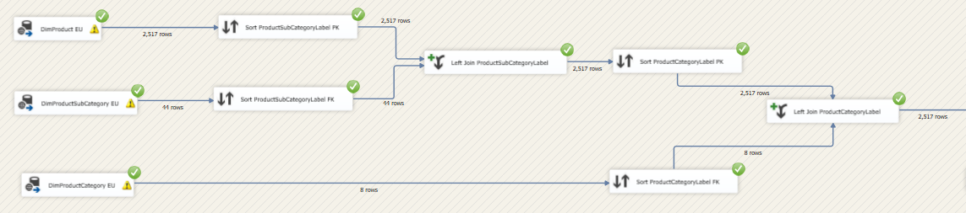

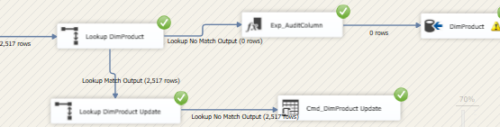

# Load Facts

FactStoreSales

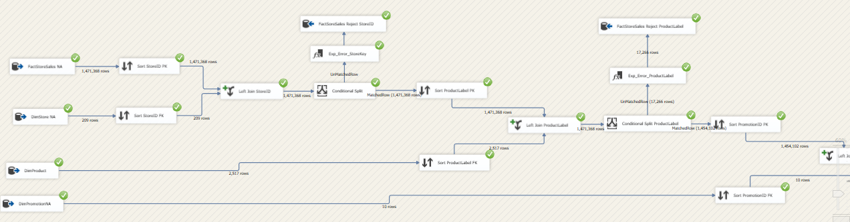

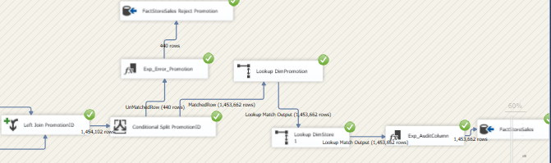

FactResellerSalesNA

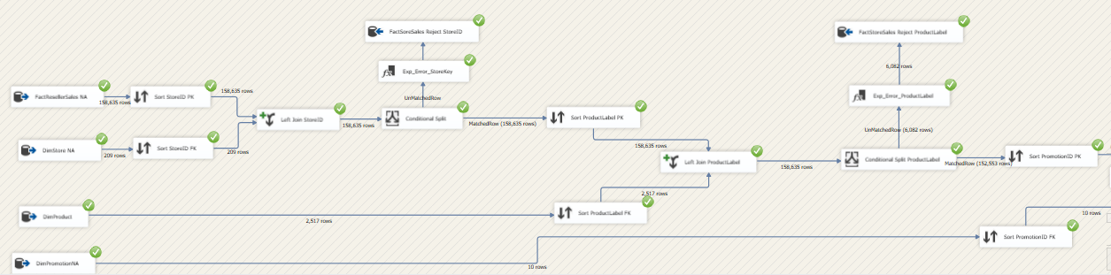

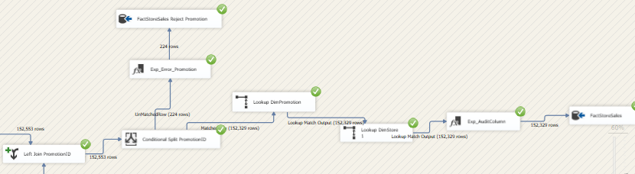

FactCatalogSalesNA

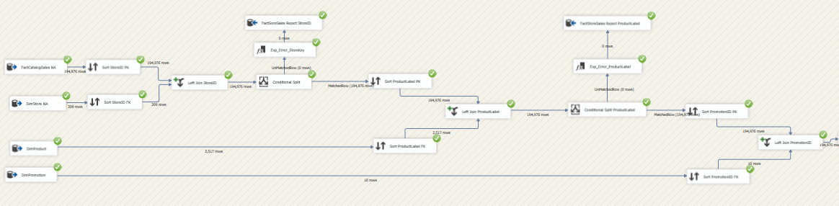

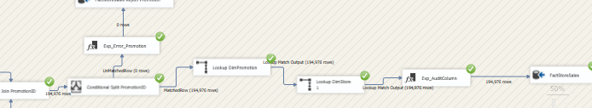

FactStoreSalesAS

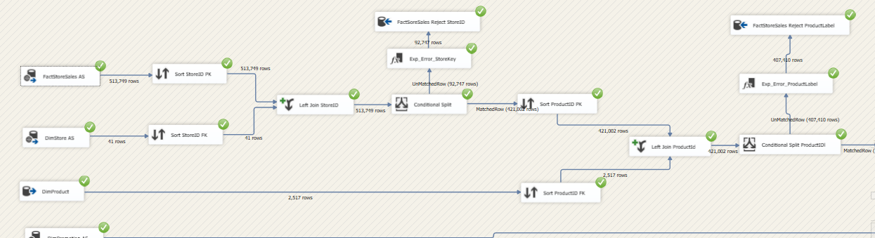

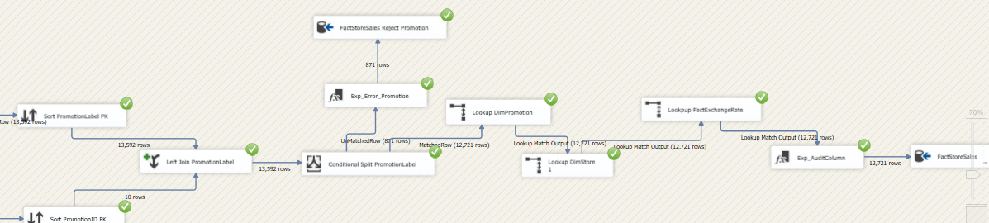

FactResellerSalesAS

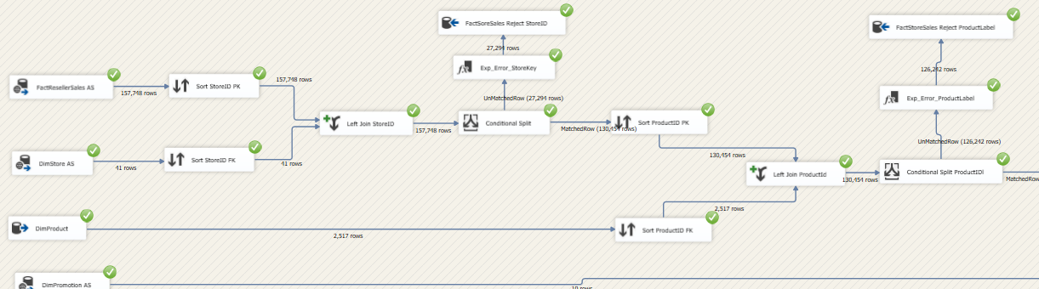

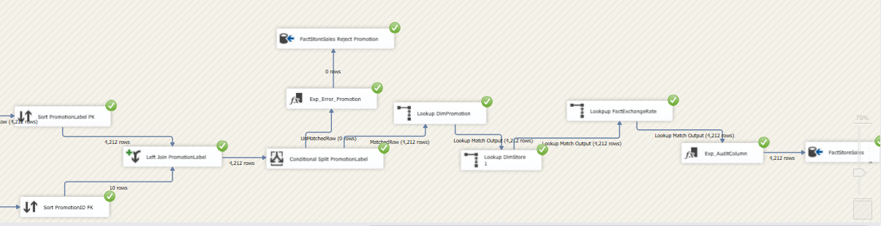

FactCatalogSalesAS

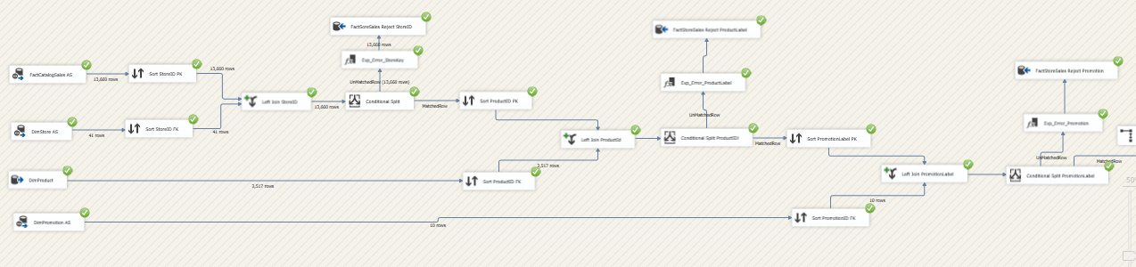

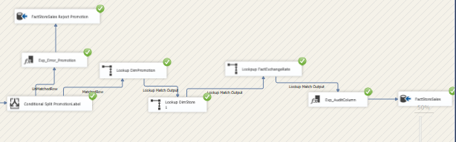

FactSalesQuota

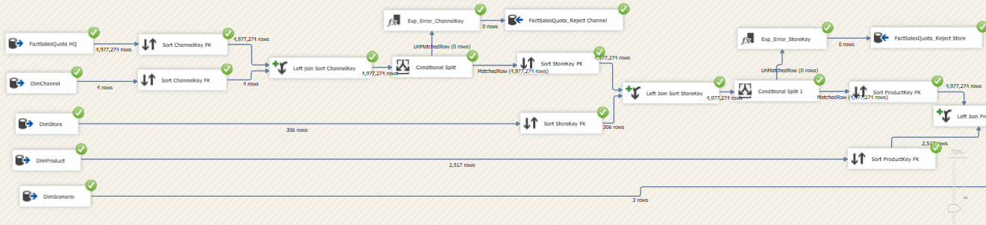

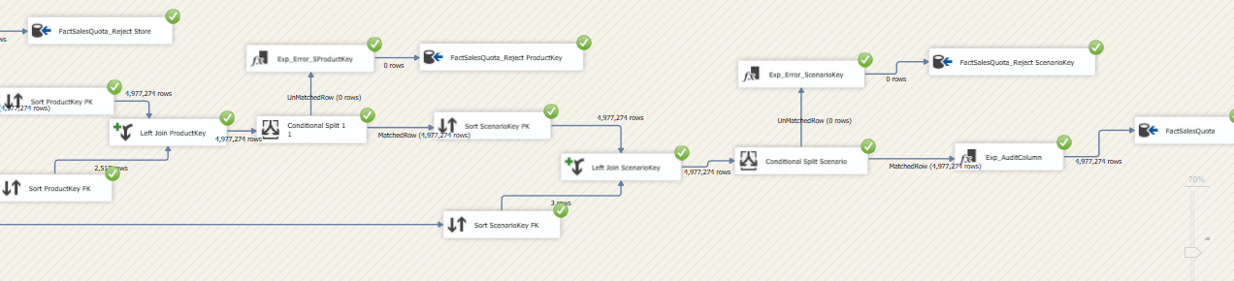

FactStoreSalesEU

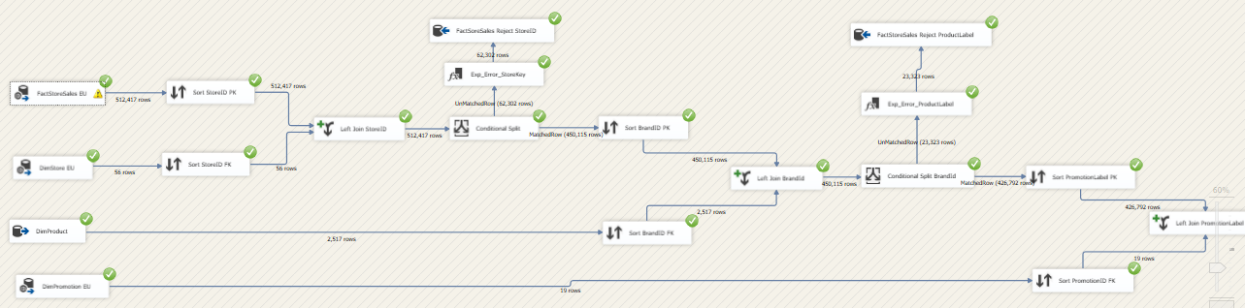

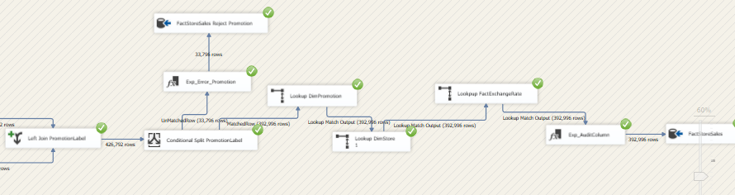

FactResellerSalesEU

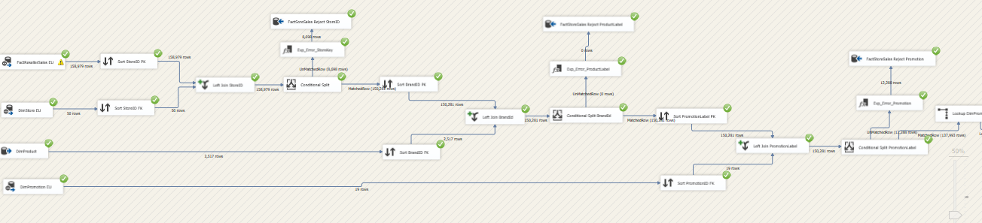

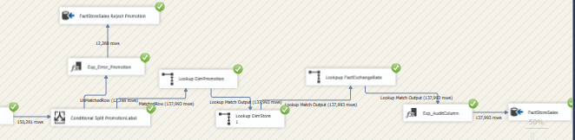

FactCatalogSalesEU

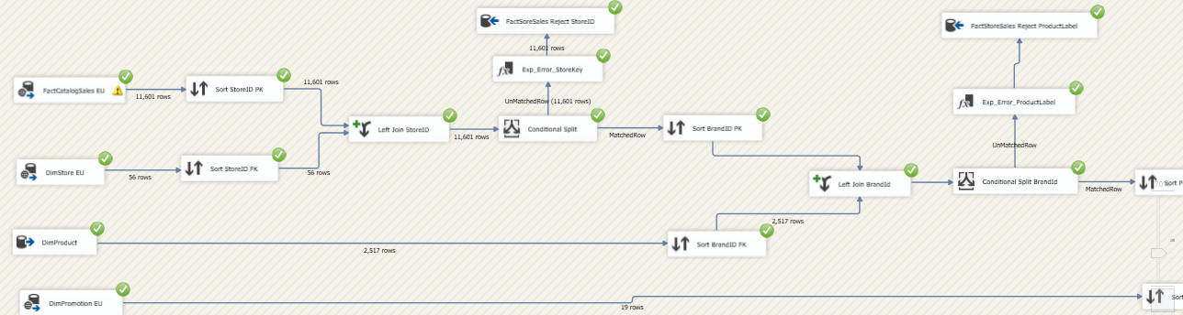

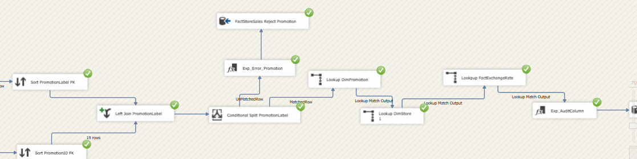

FactInventoryNA

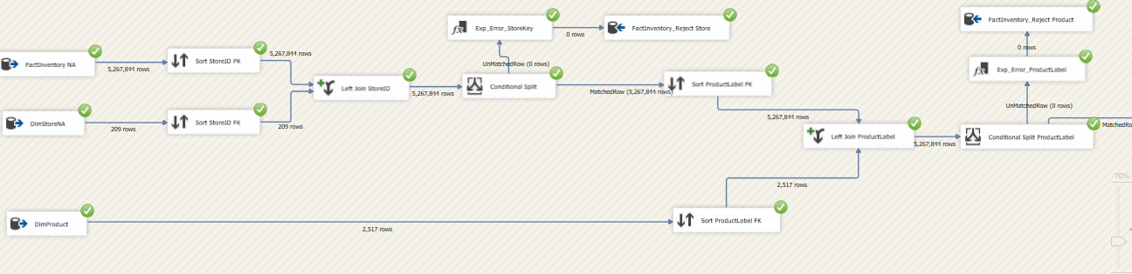

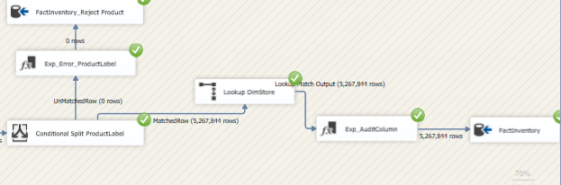

FactnventoryAS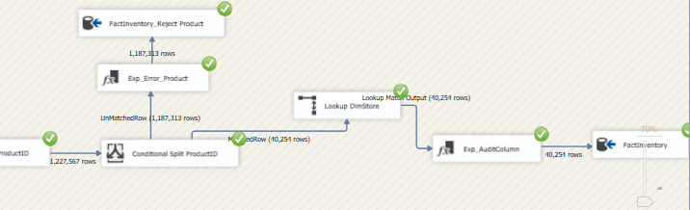

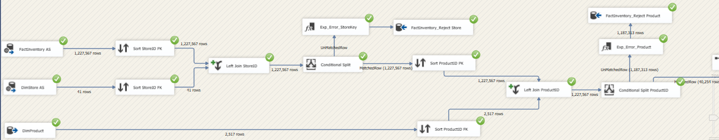

FactInventoryEU

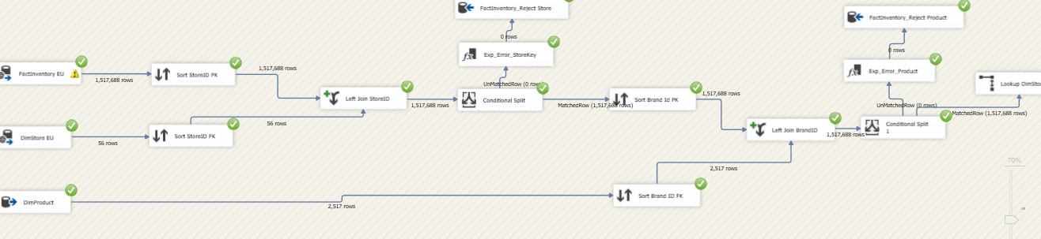

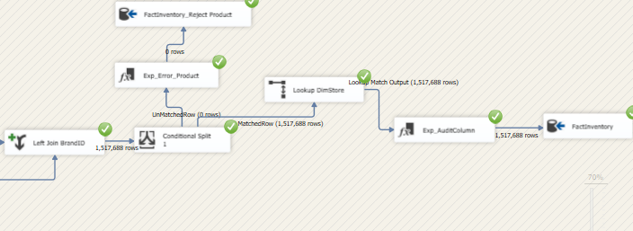

FactOnlineSales AS

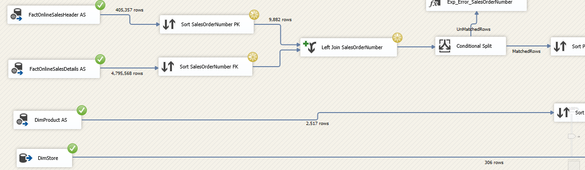

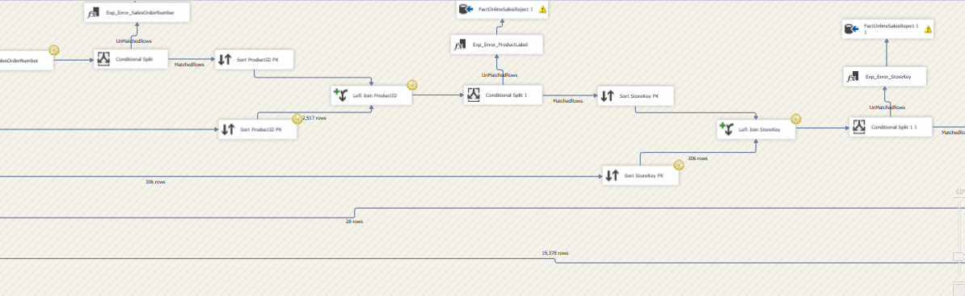

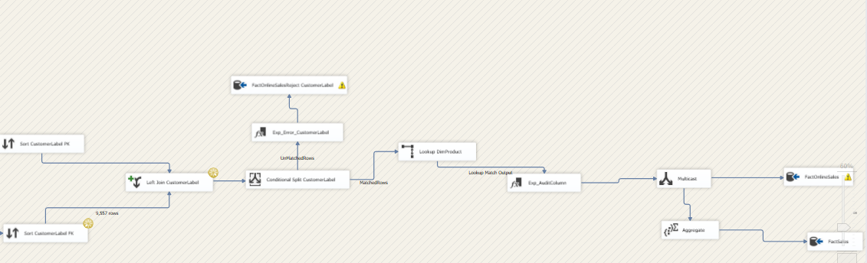

FactOnlineSalesNA

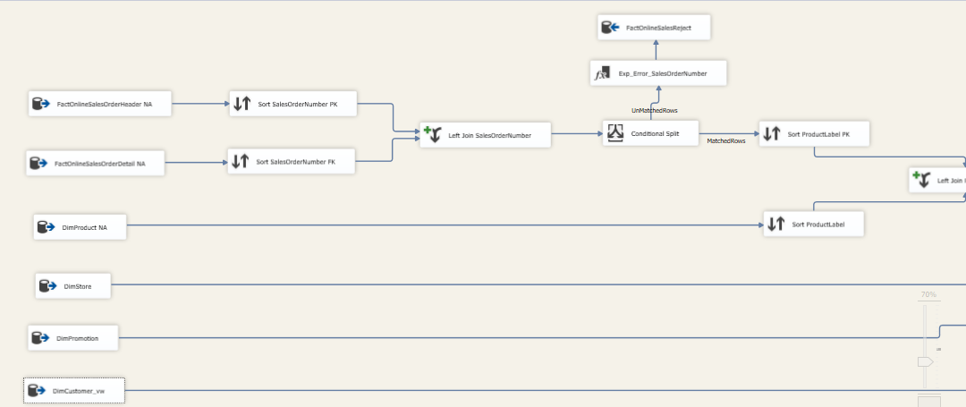

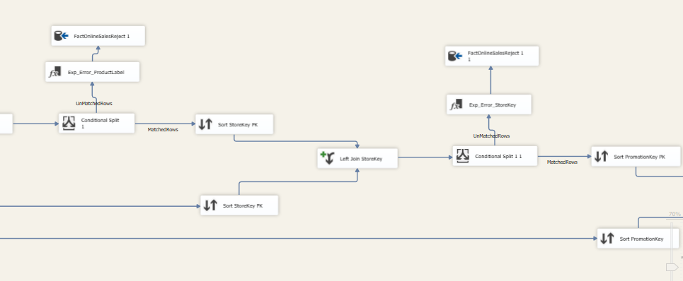

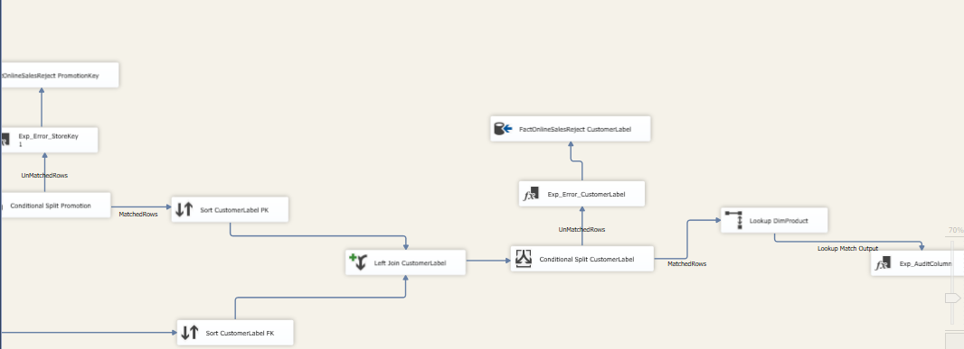

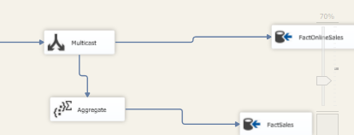

FactOnlineSalesEU

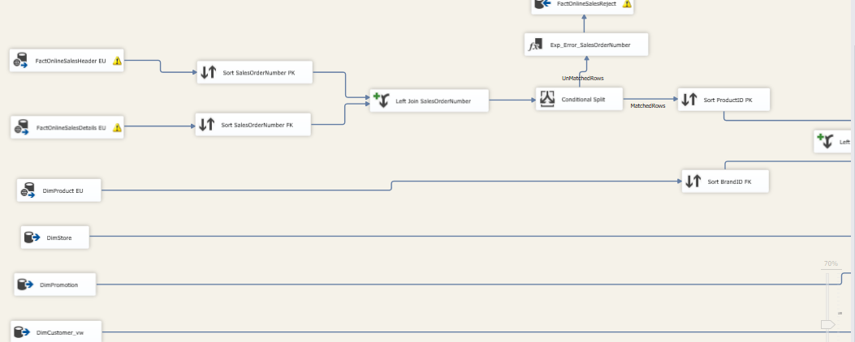

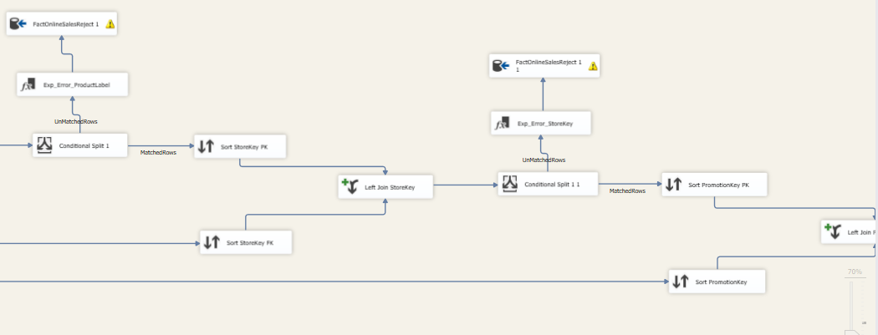

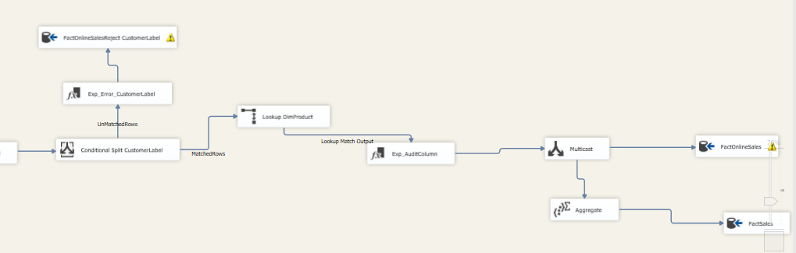

SCD

SCD ProductCost

Sheet1

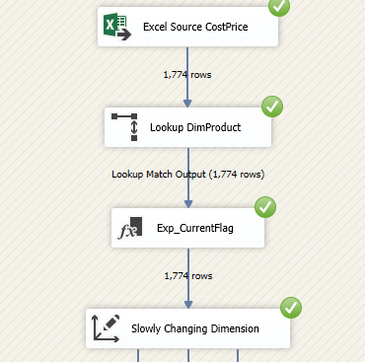

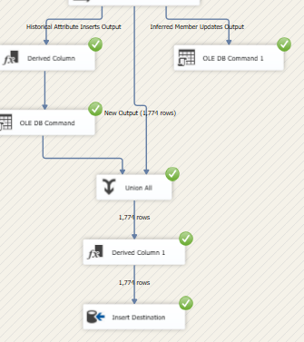

SCDSheet2

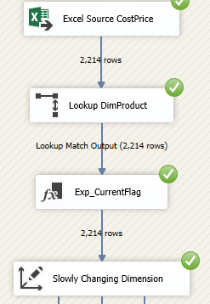 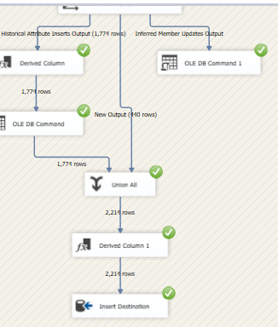

SCDSheet3

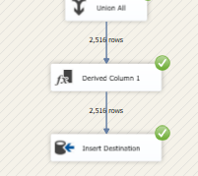

SCDSheet4

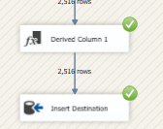

Product ListPrice SCD

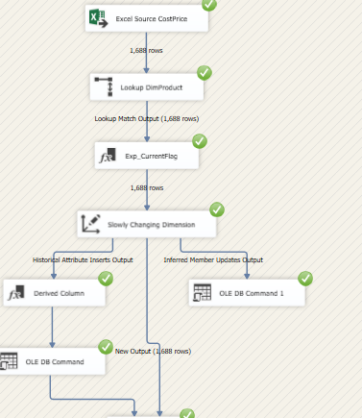

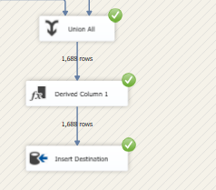

Step2

